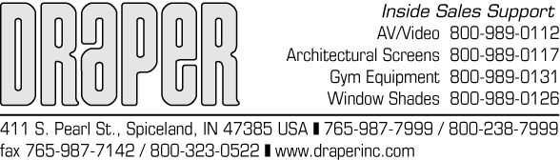

RE: MAINTENANCE DATA

PRODUCT: DRAPER WINDOW COVERING PRODUCTS

Window covering products manufactured by DRAPER, when properly installed, should require no operational maintenance or lubrication.

Most of DRAPER’S standard fabrics may be cleaned at the window by vacuuming with a soft brush attachment. They may also be cleaned using a sponge or soft cloth and mild solution of warm soapy water. A dishwashing liquid, such as Ivory liquid, is recommended.

Flocke, Obion, and Roc-Rol fabrics must be cleaned with a dry art sponge. Do not use liguids.

A clean dry cloth is recommended for the metal finish.

DRAPER, INC.

