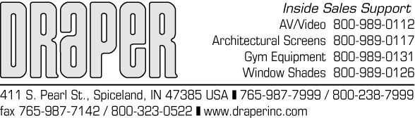

November 19, 2003

GEORGIA BLIND COMPANY
Attn: Michael Lennon
120 Howell Road
Tyrone, GA 30290

RE: MAINTENANCE DATA

PRODUCT: DRAPER WINDOW COVERING PRODUCTS

Window covering products manufactured by DRAPER, when properly installed, should require no operational maintenance or lubrication.

All of DRAPER’S standard fabrics may be cleaned at the window by vacuuming with a soft brush attachment. They may also be cleaned using a sponge or soft cloth and mild solution of warm soapy water. A dishwashing liquid, such as Ivory liquid, is recommended. A clean dry cloth is recommended for the metal finish.

DRAPER, INC.
April Ernstes
Regional Manager

ARE/ep

